Day1 Introduction to DevOps & Cloud.

Github Repo Name : cams2025-batch2-devops

DevOps = Development + Operations

Various phase of Enterprise application Development

1. Req Gathering
2. Planning
3. Coding (Unit Testing) [dev-env]
4. Testing (Integration, e2e & Acceptance Test) –[test&staging-env (pre-prod)]
5. Deployment (Running the app in Prod Env)
6. Maintenance

Full Stack Engineers – DevOps Engineers – SRE (Site Reliability Engineer)

SDLC – Water Fall Model, Spiral Model (Delivery Methodology)

CD (CI/CD – continuous Integration & Continuous Delivery/Deployment)

DevOPs = Development + Operations

DevSecOps = Methodology to do the things quickly & Automate

Steps involved in Deployments (Spring Boot backend + React Front End)

1. Checking out the latest code from Repository (github, Gitlab, bit-bucket)
2. Creating a single unit of deployment (jar/war, build folder with single optimized JS/TSfile) – Unit Test cases passed. (mvn clean install/package, npm build)
3. Ensure Security/Vulnerability (sonarqube / snyk)
4. Single Image file (with all codes, libraries, env) – using dockerfile. – hub.docker.com (docker-compose)
5. Containers – to run the image.
6. Container Orchestration - Deployment (k8s)

Automate Tools

1. Jenkins
2. Circle CI
3. Travis
4. Argo CD

Local Deployment vs Cloud Deployment

1. Local Deployment (On-prem = On-premises using bare metal machines)
2. Cloud Deployment (Virtual Machines [VMs]) – AWS, GCP & Azure

GCP free-tier (valid gmail address – debitcard/credit card) - $300 free credit .

<https://cloud.google.com> – create a free-tier GCP account.

**IMP NOTE : Removing the resources & Deleting the resources after testing it.**

1. Docker Desktop (Image & Container Mgmt tool)
2. Podman Desktop (Container & Image mgmt. Tool) – Headless mode.
3. Terraform (IaC – Infrastructure as Code)
4. Argo CD (Declarative CD Tool)
5. K8S (Container Orchestration Tool)
6. Helm Charts (K8S package manager)

Availability (99.9%, 99.99%, 99.999%) (HA- High Availability)

NFR – Non-Functional Requirements

Load Balancing

Self-Healing

Fault-Tolerance

Performance

Enable WSL2 –

WSL – Windows Sub System for Linux (turn windows feature on or off)

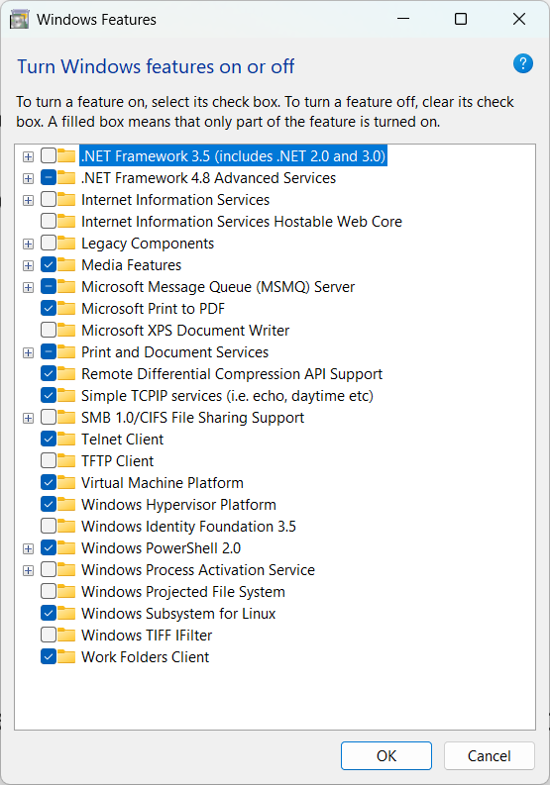



GCP – Google Cloud Platform

What is Cloud Service

* It’s a way of running the application all around the year.

Types of Cloud based on Data sharing

1. Private Cloud (dedicated resourced – costly)
2. Public Cloud (shared resources – less cost)
3. Hybrid Cloud (Moderate Cost, -- imp data in dedicated resources, less-imp data in shared resources)

3 types of Cloud based on Service

1. IaaS (Infrastructure as a Service)
2. PaaS (Platform as a Service)
3. SaaS (Software as a Service)

IAM – Identity & Access Management. (Role, Policy)

(Admin account -- )

MI – Machine Image ( OS + pre-defined set of softwares)

GKE – google K8S Engine (Managed K8S Service )

VPC – Virtual Private Cloud

TerraForm – It’s a IaC tool in DevOps (Infrastructure as Code)

<https://developer.hashicorp.com/terraform> -- Terraform is an infrastructure as code tool that lets you build, change, and version infrastructure safely and efficiently.

Main.tf (Main terraform file)

<https://developer.hashicorp.com/terraform/tutorials/gcp-get-started>

terraform [init/plan/apply/destroy] (main.tf, statefile)

Regions & Availability Zone.

Data Center – (DC)

Creating & Accessing the VM.

:WQ (Write & Quit – Save & Exit) – VI Editor

Shell (Command prompt in linux)

Bash – Bourne Again Shell

<https://www.geeksforgeeks.org/linux-unix/basic-linux-commands/>